* Spending power
* Urban people’s
* Stakeholder’s of RO based companies.
* Manufacturing companies.
* Budget
* Lack of efficient computer system
* Untrained customers
* Chemical methods
* AI techniques

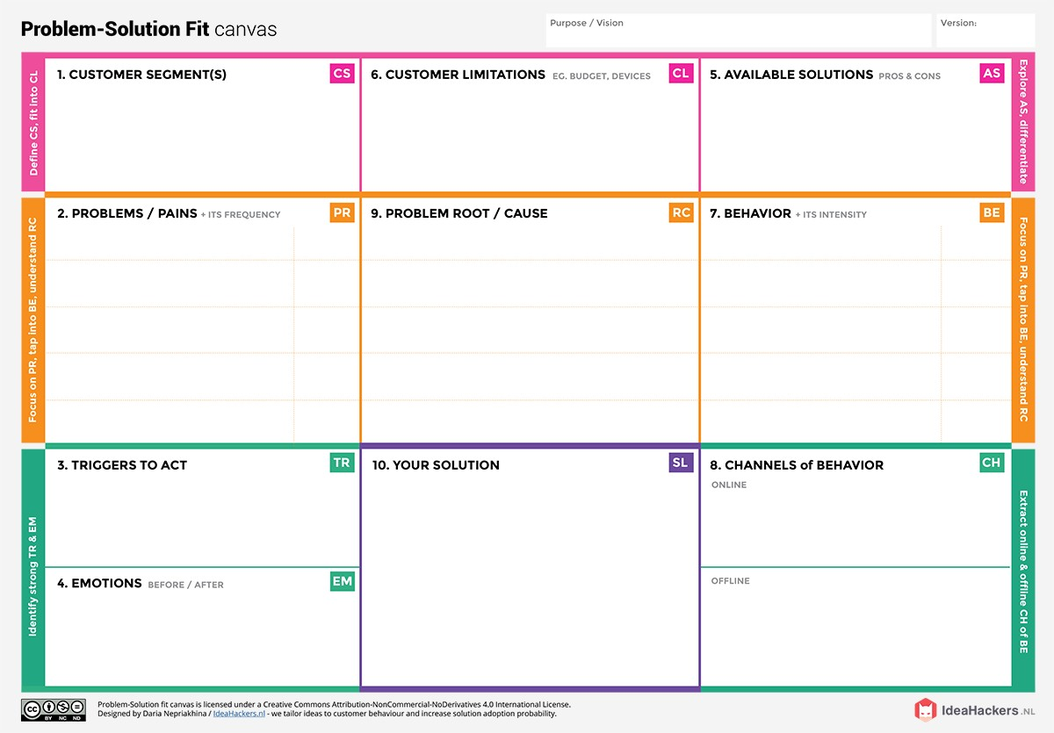

* Urban people are mostly self- employed their livelihood are not stable. So, this method will be a cost efficient method for them.
* To check whether the water quality is in compliance with the standards, and hence, suitable or not for the designated use.
* Seeing their neighbours using efficient water quality analysis method for their individual purpose.
* Reading about innovative and efficient solutions
* Before the implementation of this system people were infuriated about their water needs.
* After accomplishing this system they will be reimbursed .

People think that testing the water quality for normal usage are bad investment right now because their too expensive , and possible changes to law might influence the return of investment significantly and diminish the benefits .

This ML technique is an extension of the artificial neural network method; it has additional complex architectures that make this approach suitable for managing multi- dimensional inputs because of its high model configuration flexibility, greater generalization power, and robust learning capacity.

* Choosing of efficient providers .
* When their expected standard of water is achieved we can expect this behaviour

Extract channels from behaviour

block

Extract channels from behaviour block and use for customer development